Attachment 1 – Ashcroft Lift Station Utility Locate Map

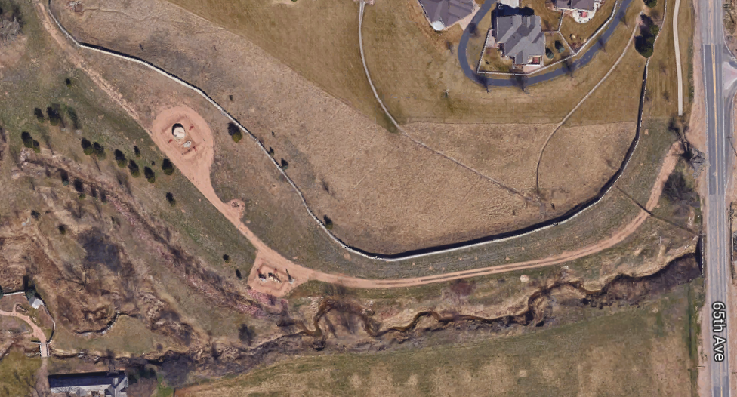
Approximate Site Location: 40.379932, -104.784940
Required Utility Locate Area

