Making Online Payments to the State

Step 1:

Visit <https://sbg.colorado.gov/liquor>.

Step 2:

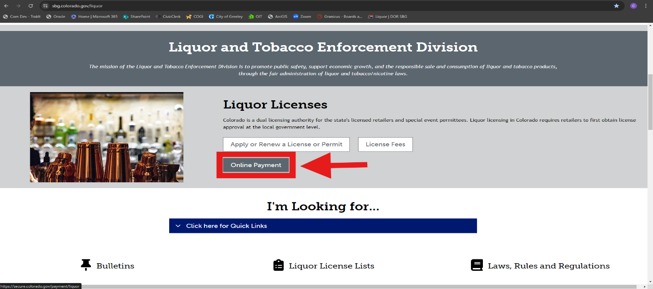Scroll down the page until you see “Liquor Licenses” in black letters. Select “Online Payment”.

Step 3:

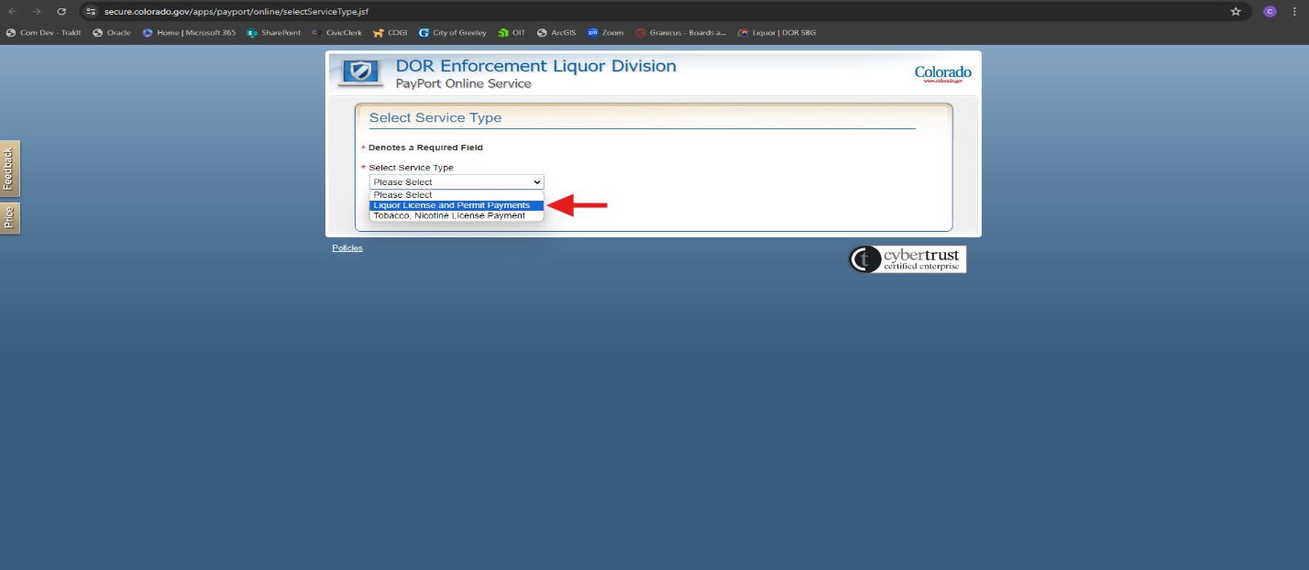 Select “Liquor License and Permit Payments” from the dropdown menu provided.

Step 4:

Enter all information required exactly as it appears on your Liquor License and the total fees you are paying to the State. Press “Continue” when complete.

Step 5:

Ensure all information is correct and select “Checkout”.

Step 6:

Complete the payment process following the prompted steps.