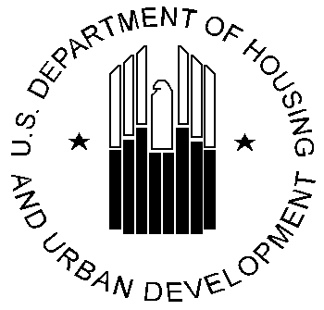
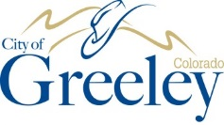
CDBG

What is CDBG? Community Development Block Grants are grants provided to larger cities and urban counties by the U. S. Dept. of Housing and Urban Development to develop viable communities through the provision of funds for decent housing, suitable living environments, and opportunities to expand economic opportunities, principally for low- and moderate-income (LMI) households. The City of Greeley annually receives approximately $840,000, 70% of which must be used to the benefit of low- moderate-income households and/or neighborhoods. CDBG is an important tool for helping the City tackle challenges facing low-income residents of the community. Greeley has received CDBG funds for more than 30 years.
How has CDBG been used in Greeley?
- Support Greeley non-profits whose mission assists LMI households, including
  - Greeley Transitional (Family) House (acquisition of facility, new roof, rehab; housing case management)
  - Guadalupe Community Shelter (acquisition, infrastructure, construction; case management support)
  - Senior Resource Services (60+ Ride) (support for transportation services for seniors 60+)
  - Greeley Center for Independence (Rehab Hope Apartments; room addition at Stephens Farm)
  - Northern Colorado Veterans Resource Center (support for veterans’ services)
  - A Woman’s Place (acquisition and rehab)
- Support City efforts to provide infrastructure (ramps, sidewalks, curb, gutter) and other amenities in low- moderate income neighborhoods, including
  - Sunrise Park, Central Greeley, Northeast Greeley, East UNC, 8th Avenue (infrastructure)
  - Kiwanis Park and Rodarte Center improvements
  - Parkway trees in Redevelopment District neighborhoods
- Support affordable housing; Acquisition of blighted properties for redevelopment
Be involved!
Be a part of the CDBG process. Learn more about the grant, 2020-2024 priorities, annual Plans and how to provide comments on Plans and Reports for submittal to HUD at one of the following 2022 meetings:
Contact GURA staff any time to learn about the City’s federal grant programs, to ask questions, or to offer comments. Or, check the GURA webpage: www.greeleygov.com/urbanrenewal
Neighborhood meetings in 2022-June 16th and July 7th (contact GURA for locations and times)
Public Hearing – GURA Board – August 10, 2022 – 4:00 (via Zoom – contact GURA)
August 11, 2022 – September 11, 2022 – Provide written comment on City’s Planned Use of Funds
Public Hearing – City Council – Date TBD-Contact GURA
2020-2024 CDBG Priorities
HIGH (most likely to receive funding)
- Support efforts to preserve, maintain, and provide access to affordable housing for homeless, low- moderate-income, underserved, and/or special needs residents. Examples:
  - Rehab grants
  - New construction of affordable housing
  - Services directly related to housing
  - Further Fair Housing
- Support efforts to revitalize neighborhoods of the Redevelopment District. Examples:
  - Install new or replace unsafe infrastructure
  - Reconstruct alleys
  - Plant trees in parkways
LOW (less likely to receive funding)
- Support public facilities (i.e. shelters, neighborhood centers, non-profit agencies) that serve the homeless, low- moderate-income, underserved, and/or special needs residents OR low- moderate-income neighborhoods.
- Support public services that serve the homeless, low- moderate-income, underserved, and/or special needs residents OR low- moderate-income neighborhoods.
For more information
Call Greeley Urban Renewal Authority – 970-350-9380
https://greeleygov.com/services/ehh/greeley-urban-renewal-authority
*********************************************************************************The City/GURA does not discriminate on the basis of disability, race, color, national origin, or gender. Persons with hearing impairments are asked to use the Relay Colorado 711 number for additional information. Other auxiliary aids and assistance related to a disability and needed to effectively review this document may call the GURA office noted above for additional assistance. (Please allow 48 hours for requests to be processed.) For more information, or to file a complaint, please contact the City of Greeley’s designated Disability Rights and Title VI coordinator, Will Jones at 970-336-4029, 1100 10th Street, Greeley, CO, 80631, or at will.jones@greeleygov.com.
*********************************************************************************

