The City of Greeley takes great care in treating and protecting your water supply. Controlling cross-connections with backflow prevention is an important risk management strategy. The city has dedicated water utility staff who work with commercial, industrial, multi-family, and large irrigation customers to ensure these users consistently maintain and test their backflow prevention devices.

The following FAQs help you understand the city's backflow prevention and cross-connection control program and the current public notice for backflow violations. Our customers deserve to know what happened and what we are doing to correct this situation.

- Is my water safe to drink?
Yes! The city’s water has been consistently safe, and there are no indications of a backflow event. Greeley regularly monitors water quality throughout the distribution system and ensures all parameters are within regulatory limits. The city’s water remains safe for drinking, cooking, bathing, and irrigating.

- Why is the city sending a public notice and what do these violations mean?
The City of Greeley is sending public notices to all customers because the city’s public water system received two violations from the state in our Backflow Prevention and Cross-Connection Control program. These violations stemmed mainly from record-keeping issues. The city is responsible for ensuring that customers with backflow assemblies maintain them properly. The City of Greeley is working diligently to strengthen the Backflow Program data, has hired additional staff, and has directly contacted properties with untested assemblies to ensure they comply.

- What is a backflow prevention device?
A backflow prevention device is used to protect potable water supplies from the potential for contamination or pollution that could impact water quality due to backflow.
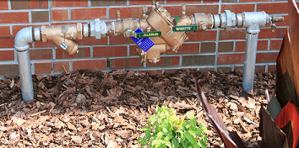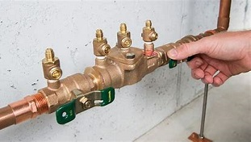
- How do backflow assemblies protect my water quality?
Backflow assemblies are an added line of defense to ensure that water only flows one way through water pipes, from the public water system into businesses and homes, never the other way around. Regulations require certified testers to perform annual tests on backflow prevention assemblies to verify they work correctly.

If you have further questions about the notice's content, please contact Greeley Water at backflow@greeleygov.com or 970-350-9811, Option 2.

For more information about backflow and cross-connections, please visit Greeley’s Backflow and Cross-Connection Control Program webpage at greeleygov.com/cross-connection

