**SpryBackflow**

Tester User Guide



|  |
| --- |
| **City of Greeley** **Tester Registration & Certification** |
| At the City of Greeley, backflow testers are required to be certified by either ABPA or ASSE. Testers submit their certification and test equipment calibration documentation.  Testers can enroll for the SpryBackflow portal by entering their certification documentation, test equipment details and certification, and their personal information. Testers will not have access to the SpryBackflow portal until the City of Greeley’s program administrator approves the registration. In the situation where a backflow tester has multiple certifications there can be an optional data entry for “Secondary Certification” as seen in the following figure. |

## **Logging In**

Testers will see the same login page and can also use the “**Forgot Password?**” link for their accounts. They can use the “**Click Here to Enroll**” button to input their tester information and register to use the portal.

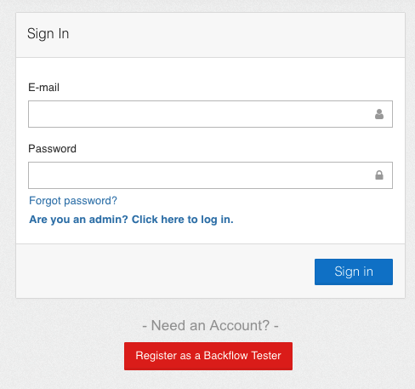

New testers will have the option to register as a new Backflow Tester for the system.

## **Tester Registration**

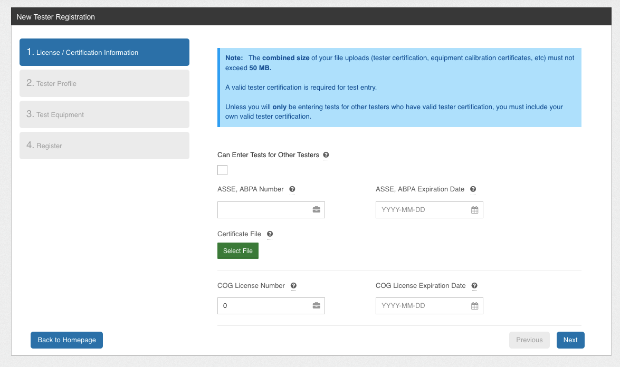

From the New Tester Registration Portal the first page will be for License / Certificate Information.

Here the ASSE or ABPA Number of your certificate will need to be provided, alongside the certificate expiry date and upload of your certificate.

If you are entering tests on behalf of another tester you may select the selection box “Can Enter Tests for Other Testers”.

The City of Greeley license number and license expiry date will need to be entered as well.

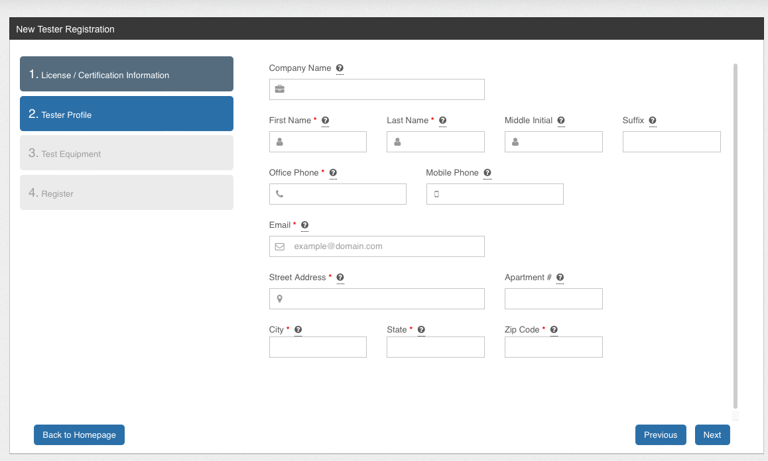

Tester Profile information will need to be provided, including your contact information, and company name if applicable.

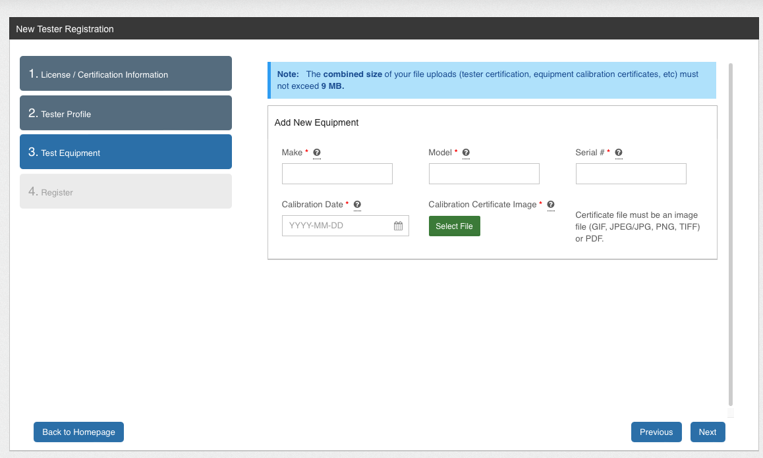

Testers will be required to add at least one equipment type for their profile into the system. Asking for the Make, Model, Serial #, and calibration date. Multiple entries can be added.

Please Note:

Test results can only be submitted within 12 months of the calibration date of the equipment listed. Please ensure your test equipment is up to date to prevent delays in testing.

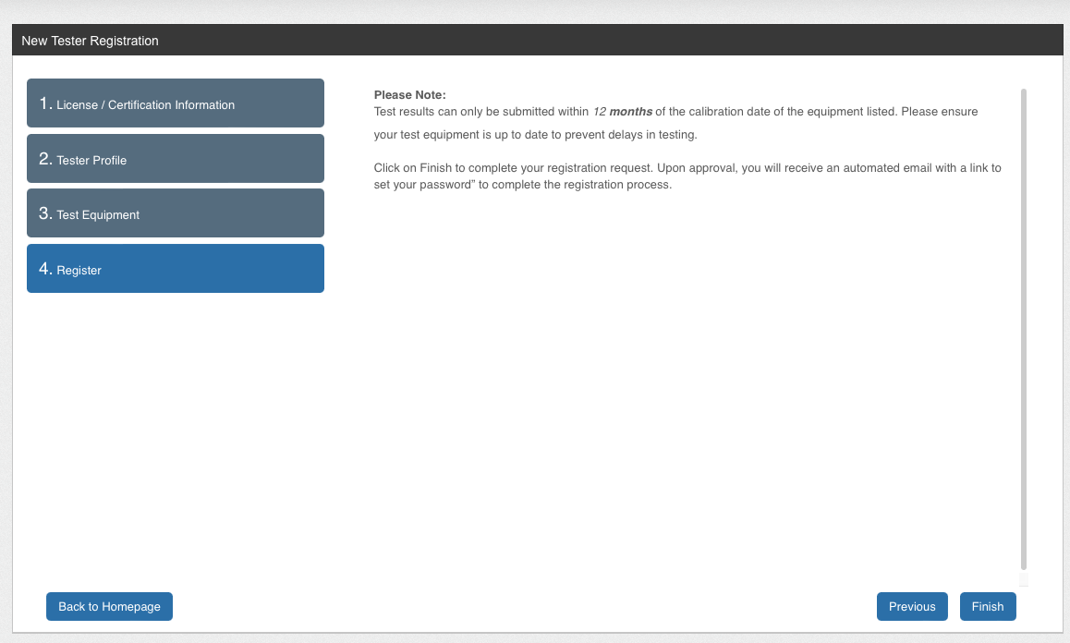

Click on Finish to complete your registration request. Upon approval, you will receive an automated email with a link to set your password” to complete the registration process.

## **Finding Assembly Test**

If the organization’s test submission method is “Test PIN”, a unique access code/Test PIN is generated by the system and provided to the tester. This Test PIN can be entered manually by an admin, generated by button click, or automatically generated during the first step of any test notice schedule. It will be provided to the customer in one or more of the test notices and they must give it to the tester. Admins can also access and provide this information if needed.

The tester enters the Test PIN on the homepage of the tester portal to find the correct assembly location, and starts the test from there.

*Figure: Assembly test search options for Test PIN configuration*

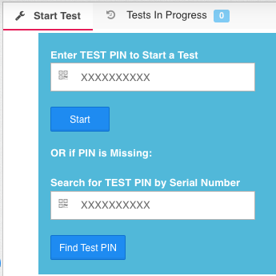

If the organization’s test submission method is “Assembly Location Search”, there will be no PIN associated with an assembly location. Instead, the tester can enter information about the assembly location (such as the address, equipment ID, or serial number) on the homepage of the tester portal to find the correct assembly location and start the test from there.

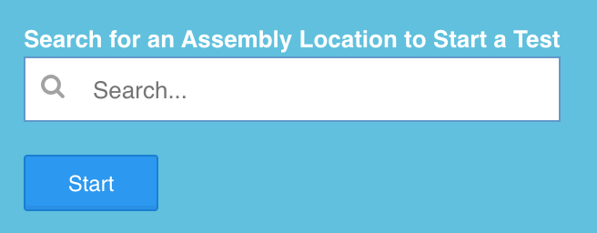

The second configuration option will be used to allow the testers to freely search for an assembly to start a test.

## **Assembly Test Workflow**

*Figure: Assembly Test wizard pages*



If device type selection is enabled in the organization config, the tester is prompted to select what device type the assembly is. When they proceed to the next step, they will receive a pop-up confirmation warning them that they cannot change the device type after this point. Once they hit okay on the confirmation window, the device type is locked in.

If the device type is different from what is in the system, it will need to be confirmed by the reviewing admin at the time of review.

The tester is prompted to check that they have selected the correct assembly for testing. They have the option to replace the assembly at this point. They will also have a similar option during the retest.

If replacing the assembly, it is a “like for like” change (RPA to RPA, DC to DC, etc). For Unlike changes, the tester must contact a City of Greeley administrator. After filling out the fields in the replace assembly modal and checking the box for 'replaces assembly', they can continue with the regular test/retest workflow.

The tester selects the test equipment from the list of the test equipment they added to their profile. They must select one with a valid calibration to proceed.

The tester fills out the initial assembly test. They are provided with validation to know if the initial test has failed or not. If the initial test fails, they will receive a prompt to complete a retest after repairs. Like the device type selection, there is a confirmation window for the initial test results. Once this is okayed, the initial test results can no longer be changed.

*Figure: Confirmation message when submitting initial test results*

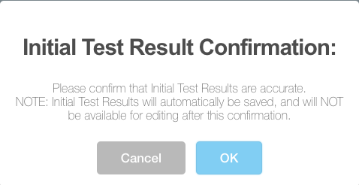

**Retest Workflow:**

After the initial test results are submitted, if any of the validates are flagged as “Failed” then the initial test is marked as Failed. The tester has the ability to complete a retest which includes data entry for “repairs and materials used” and “retest comments”. The retest must pass in order for the assembly test to be submitted.

**Test Submission / Digital Signature:**

The tester checks the signoff confirmation and submits the test. After submission, they have the option of emailing the location contact.

*Figure: Test submission digital signature required checkbox*

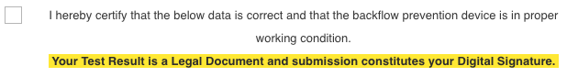

Previous step or submit results buttons. 

**Failed Test Workflow**

The City of Greeley currently does not have this ability but was interested in the SpryBackflow process. If the failed test workflow is enabled a new option will appear on the re-test page of the assembly test. The Failed Test workflow will allow the tester to submit the backflow assembly test as a “Failed Initial Test Without Repairs/Re-Test.”

*Figure: Message and digital signature box that appears on re-test page if failed test workflow is enabled*

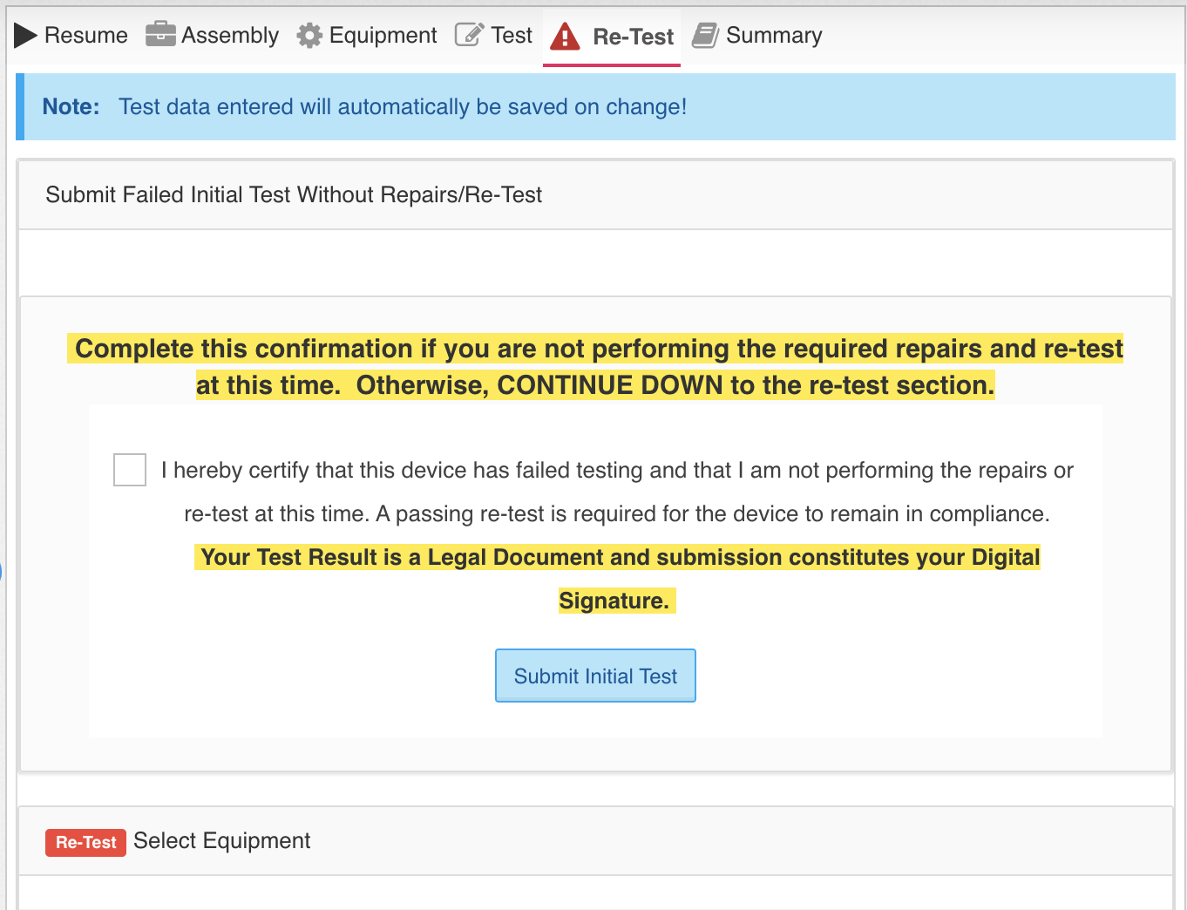

When the tester submits a failed initial test, it will appear in the admin side under the Assembly Test page and can be found using the “Failed First'' filter. The backflow device will also be placed in the Failed Test Notice Schedule which will allow the utility to send out a different set of notices (letters, emails, text messages) to tell the customer to get their device retested before being shut off.